# Introduction

The Alfresco PDF Toolkit is a set of extensions for Alfresco that add functionality for the manipulation and management of PDF documents. These actions include:

Append pages to PDF

Insert pages into a PDF

Delete pages from a PDF

Split a PDF at a defined page

Split a PDF at a defined interval

Watermark a PDF document with images or text (including document metadata)

Digitally sign a PDF

Encrypt a PDF (with feature restrictions, if required)

Convert a PDF to the archival PDF/A format

# Installation

The Alfresco PDF Toolkit is shipped as a set of AMP files, one for the repository tier and one for Alfresco Share. If you are not using Share, or only require the repository actions for use in your own code, you can safely omit the Share AMP file. These AMPs are installed just like any other extension to Alfresco, using the MMT (Module Management Tool).

Once the modules are installed, a new set of actions is available for use. These actions are also exposed via the Share user interface by default. To see the list of actions exposed via Alfresco Share, go to the Share Module deployment page at:

http://<host>:<port>/share/page/modules/deploy

If the Share modules are installed correctly, you should see a list of available modules that looks something like this:

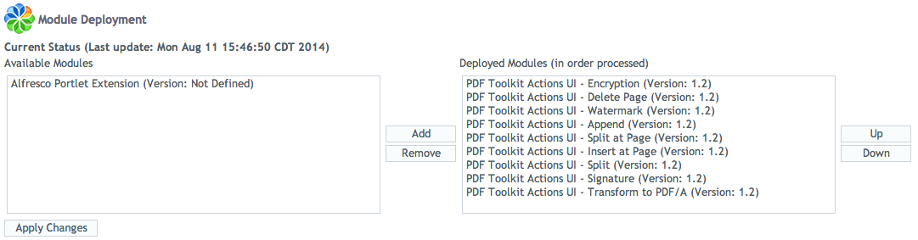

From this page you can remove any of the PDF toolkit modules that you might want to hide from Share users. Note that this does not disable the repository actions, only the user interface components.

